
Real-Time Open-Source Transaction Monitoring

Alert Triage Module
Business Requirements Document
Authors: Justus Ortlepp - Tazama
June 2025

Table of Contents
Document change Log 4
1 Introduction 5
1.1 Tazama System Overview 5
1.2 Document Purpose 6
1.3 Implementation Assumption 7
1.4 Additional Considerations 7
2 Use Cases 9
System Context 9
System Actors 9
Use Case Diagram 10
State Diagram 11
High-Level Case Management Process Flow 11
2.1 Create a New Case 12
2.2 Complete Case Creation 21
2.3 Approve Case Creation 25
2.4 Assign (Reassign) a Task 30
2.5 Investigate a Case 34
2.6 Unassign a Task 40
2.7 Suspend a Case 44
2.8 Resume a Case 48
2.10 Close a Case 51
2.11 Approve Case Closure 54
2.12 Reopen a Case 58
2.13 Approve Case Reopening 61
2.14 Other Use Cases 65
2.15 Reporting 67
3 General requirements 71
3.1 System Logging 71
3.2 Audit logging 71
3.3 Audit Logging vs System Logging 72
3.4 Structured Event Logging 73

Introduction

Tazama System Overview
The Tazama Transaction Monitoring System is a rules-based forward-chaining inference engine that ingests transaction data as JSON-formatted ISO20022 messages and evaluates the data in real-time. Tazama uses a number of pre-built and configured rule processors to look for fraud and money-laundering behaviors. Rule results are summarized into fraud and money-laundering scenarios (known as typologies) and the system is able to block or flag transactions if typologies breach configured thresholds.
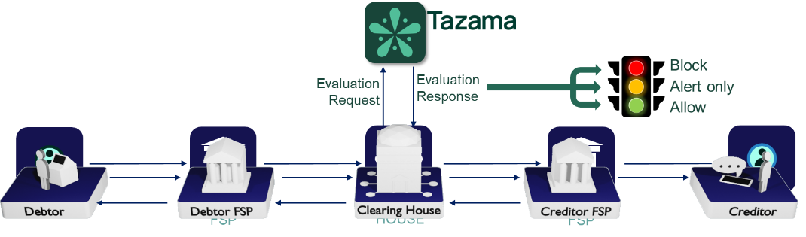
The core detection capability within the platform is distributed across 3 distinct steps in the end-to-end evaluation flow.
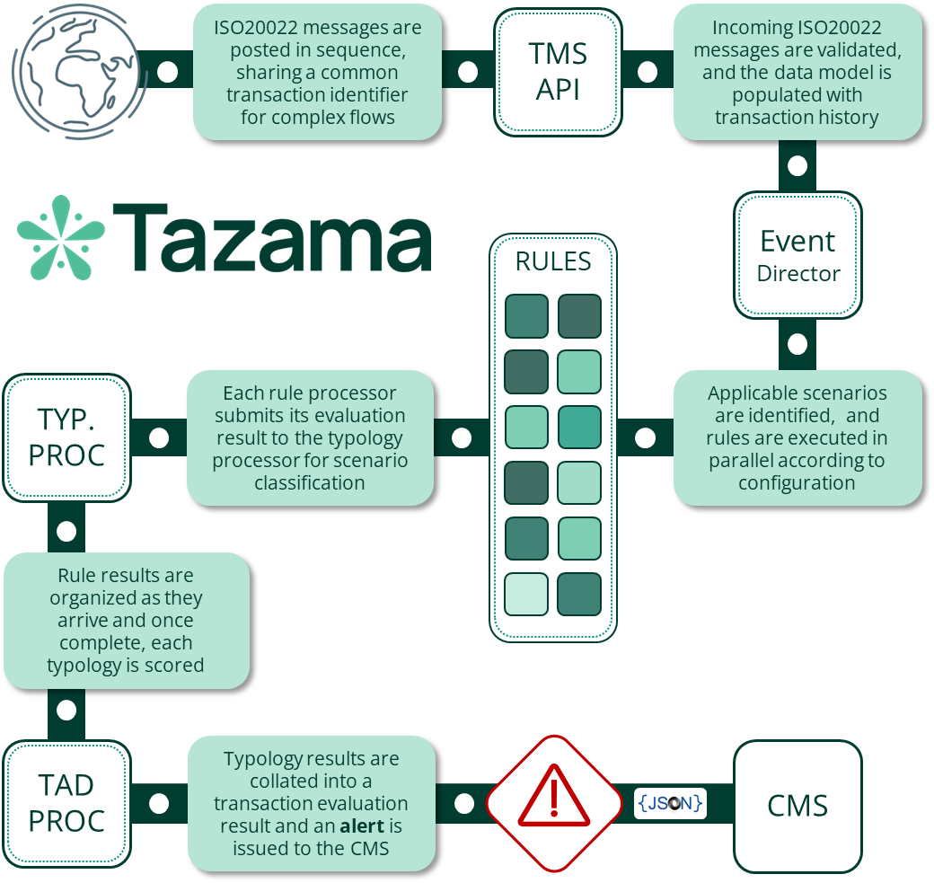
Once data is ingested into the transaction history by the TMS API, the Event Director (ED) performs an initial "triage" step to determine if the transaction should be inspected by the platform, and in what way. Currently this is a very simple decision based on the transaction type only (i.e. pain.001, pain.013, pacs.008 and pacs.002), though we envisage that the decision-making here can be more complex in the future by inspecting attributes contained in the message. For now, the ED uses the transaction type to select the typologies that are to be evaluated and triggers the rules required by the typologies. The ED routing is configured via a network map that defines the hierarchy of typologies and rules.
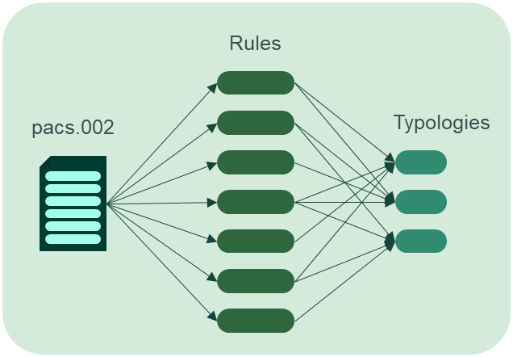
Each rule processor that receives the trigger payload from the Event Director evaluates the transaction and the historical behavior of the transaction participants according to the rule’s specification and configuration. Rule processors are driven by a combination of parameters and result category specifications to determine only one of a configurable set of related outcomes. The rule outcome is then submitted to the typology processor for scoring.
The typology processor assigns a weighting to each rule outcome as it is received based on the rule’s parent typologies’ configurations. Once all the rule results for a specific typology have been received, the typology adds all the weighted scores together to form the typology score. The typology score can be evaluated against an "interdiction" threshold to determine if the client system should be instructed to block a transaction "in flight". The typology configuration also contains an investigation threshold that will trigger a review or investigation process at the end of the transaction evaluation.
Once these three steps are complete, the evaluation of the transaction is wrapped up in the Transaction Aggregation and Decisioning Processor where the results from typologies are combined and reviewed to determine if an investigation alert should be sent to the Case Management System. If any typology had breached either its investigation or interdiction threshold, the system would trigger an investigation alert for that transaction.
The Tazama system is currently provided as a software engine and as such is generally implemented as a back-end service that taps into transaction flows.

Document Purpose
The Tazama features project undertaken by Paysys Labs in preparation for an implementation at COMESA involves the extension of Tazama's core transaction monitoring capabilities into a Fraud Risk Management ecosystem of components. As part of that ecosystem, we will deliver a Case and Investigation Management System.
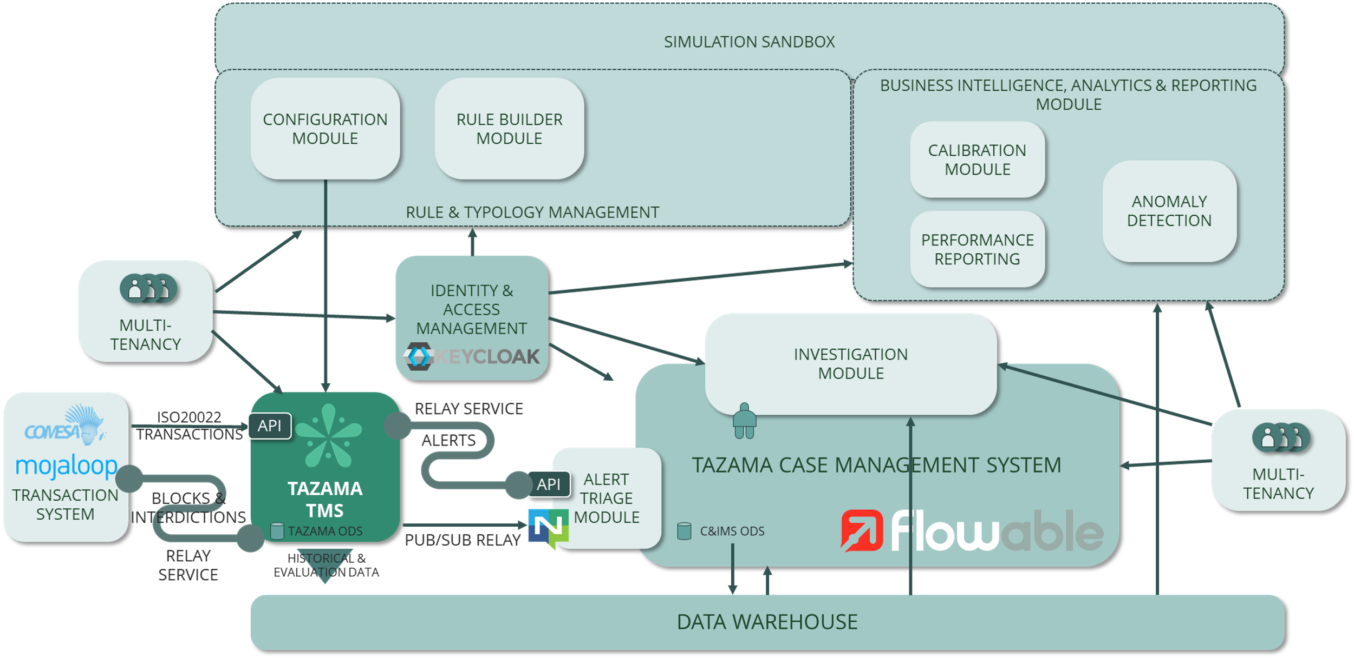
Every alert that is generated out of the Tazama Transaction Monitoring Service (TMS) must be investigated to either confirm or refute the suspicious behavior identified by the TMS. This is firstly required to maintain the good health of the monitoring service itself, but if suspicious behavior is confirmed, the operator of the TMS also has an obligation to investigate the alert for fraud and money-laundering regulatory and legislative enforcement purposes.
The Case and Investigation Management System provides the processes and the tools to assist investigators in the fulfilment of this obligation.
The Case and Investigation Management System will also contains an AI-powered Alert Triage Module that tries to automatically validate, classify and prioritize the alerts generated out of the TMS before an investigator is assigned to minimize unnecessary investigative effort.
The purpose of this document is to provide the requirements for the delivery of the Alert Triage Module as part of the Case Management System.

Use Cases

Process Overview
Case Management covers the specific processes related to the creation and management of cases. One of those processes is an initial Alert Triage step which aims to minimize manual effort in investigations by predicting whether an investigation would confirm or refute an alert.
The purpose of this section is to define the roles, responsibilities, and processes involved in alert triage. The overall alert triage process is described in the following diagram:

Narrative
The processes (use cases) for Create a new case, Close case and Investigate a case are documented in the requirement specifications:
- Tazama CIMS Part 1 - CMS - 20250430 v1.1 Final
- Tazama CIMS Part 2 - Investigation - v1.0 Final Draft
A new case can be created automatically when an alert is received from the Tazama Transaction Monitoring System (TMS) or manually when a CMS user is required to create one.
When an alert is received from the Tazama TMS, the alert data must be routed to an automated alert triage process. A manually created case must be handled manually.
The alert triage process must compare the received alert to previously received and investigated alerts to determine, with a high level of confidence, if the alert requires investigation or if the alert can be closed automatically.
If the required confidence level (configured by default to be 95%) is not achieved, the alert must be investigated.
If the confidence level is met, the alert can be closed automatically, depending on if a transaction had been allowed, or if the alert identified a suspicion of money-laundering. If the transaction had been blocked by the Tazama TMS, or if the alert does not indicate money-laundering, the alert can be closed safely.
If the alert triage process indicated a false positive result, then the alert can be closed immediately, with a closed status of "72 - AUTOCLOSED REFUTED". (If this outcome eventually turns out to be incorrect, the case can be reopened for an investigation.)
If the alert triage process indicated a true positive result (i.e. the alert was confirmed) and a transaction had not taken place, or does not indicate a suspicion of money-laundering, then the alert can be closed immediately, with a closed status of "71 - AUTOCLOSED CONFIRMED".
If the alert triage process indicated a true positive result (i.e. the alert was confirmed) and a transaction had taken place, the alert must be investigated regardless since fraud had actually occurred.
If the alert triage process indicated a true positive result (i.e. the alert was confirmed) and a suspicion of money-laundering was indicated, the alert must be investigated regardless since suspicion of money-laundering must always be investigated and reported to a regulator.
A case that is to be investigated must be prioritized according to the information available in the alert to ensure efficient application of limited resources.
Assumptions:
- A case must always be created for workflow and outcomes to be tracked in the CMS.
- A manually created case does not require automated triage because the case is already under a user's control and will have been created based on information other than a system alert.
- A case for an alert that has been confirmed and where the transaction had occurred must be investigated because the alert indicates that fraud had occurred (i.e. fraud was not prevented).
- A case for an alert that has been confirmed and where a suspicion of money-laundering was indicated must be investigated.
- A case for an alert that has been refuted, or confirmed and where the transaction had not occurred (i.e. fraud was prevented), or no suspicion of money-laundering was indicated, does not require investigation.

System Actors
The intended users/beneficiaries of the alert triage system can be classified into three distinct actor categories:
Primary Actors (these are direct users of the system):
- Administrators - Interaction with the system configuration and administration functions
- Investigator/Analyst - Tier 1 (initial/maker) interaction with the system case management functions
- Supervisor - Tier 2 (supervisory/checker) interaction with the system case management functions
- Upstream/downstream systems - Direct active/input interaction with the system in an automated fashion

Secondary Actors (these are users who rely on the outcomes of the system). Secondary actors are not generally expected to be direct users of the system, and will instead receive outputs from the system, or have a vested interest in the tasks that the system performs, and the way these tasks are performed.
- Downstream systems - Passive/listener recipient systems of the system output
- Operational Managers - Oversight and reporting on efficient system and user operations
- Compliance Officers - Oversight over the adherence to compliance policies
- Auditors - Audit adherence to fraud management policy, process and procedures. These may include both internal and external auditors
Tertiary Actors (these are users who have a vested interest in the existence or outcomes of the system)
- Regulators - Industry oversight and Fraud Risk Management policy guidance or directives

Use Case Diagram
The following diagram provides an overview of the various system users (actors) and their anticipated user objectives (use cases):

Triage new case

Description
The Case and Investigation Management System must contain an AI-powered Alert Triage Module that attempts to automatically validate, classify and prioritize the alerts generated out of the TMS before an investigator is assigned to minimize unnecessary investigative effort.

Actors

Primary Actor
- Case Management System: The CMS invokes the alert triage module when a new alert is received from the Transaction Monitoring System.

Supporting/Secondary Actors
- Supervisor / Manager / Compliance Officer / Auditor:
- May need to review alert triage overturned alerts report
- Compliance Officer / Auditor (External Stakeholder): May later review logs or confirm compliance with regulatory or internal policies, though not triggering the creation directly.

Pre-conditions

Infrastructure / Configuration Ready
- The alert triage module has been configured as part of the case management workflow.
- The alert triage module confidence threshold has been configured.
- Relevant compliance logging is active (GDPR, ISO 27001) so that any triage event is captured.

Triggers
- The Case Management System has received a new alert from the Transaction Monitoring System.

Main Success Scenario (Ideal Path)
- Create a task "Triage Alert"
- Assign the "Triage Alert" task to the Alert Triage Module
- Predict investigation outcome
- Update "Triage Alert" task
- Close new case

Partial Success Criteria

Case flagged as true positive, but alert indicates money-laundering
The case was flagged as a true positive with high confidence, but the alert indicates a suspicion of money-laundering, and the case must then be investigated.
- The "Triage alert" task is updated with the prediction outcome
- The "Triage alert" task status is "30 - COMPLETE"
- The case is assigned a priority
- Refer to the outcomes for 2.1.7 Complete Success Criteria (2.1 Create new case) in the Tazama CIMS Part 1 - CMS - 20250430 v1.1 Final requirements specification.

Case flagged as true positive, but transaction occurred
The case was flagged as a true positive with high confidence, but the transaction had actually been allowed, and the case must then be investigated.
- The "Triage alert" task is updated with the prediction outcome
- The "Triage alert" task status is "30 - COMPLETE"
- The case is assigned a priority
- Refer to the outcomes for 2.1.7 Complete Success Criteria (2.1 Create new case) in the Tazama CIMS Part 1 - CMS - 20250430 v1.1 Final requirements specification.

Confidence level below configured threshold
The ATM predicted an investigation outcome with low confidence, and the case must be investigated.
- The "Triage alert" task is updated with the prediction outcome
- The "Triage alert" task status is "30 - COMPLETE"
- The case is assigned a priority
- Refer to the outcomes for 2.1.7 Complete Success Criteria (2.1 Create new case) in the Tazama CIMS Part 1 - CMS - 20250430 v1.1 Final requirements specification.

Complete Success Criteria
- If the ATM predicted that an investigation will confirm the alert:
  - The "Triage alert" task is updated with the prediction outcome
  - The "Triage alert" task status is "30 - COMPLETE"
  - The case status is "71 - AUTOCLOSED CONFIRMED"
- If the ATM predicted that an investigation will refute the alert:
  - The "Triage alert" task is updated with the prediction outcome
  - The "Triage alert" task status is "30 - COMPLETE"
  - The case status is "72 - AUTOCLOSED REFUTED"
- Refer to the outcomes for 2.1.7 Complete Success Criteria (2.1 Create new case) in the Tazama CIMS Part 1 - CMS - 20250430 v1.1 Final requirements specification.The creation of the task(s) is audit logged
- The creation of the "Triage alert" task is system- and audit-logged
- The assignment of the "Triage alert" task is system- and audit-logged
- The outcome of the triage process is system- and audit-logged

Extensions
2 The alert triage module is not enabled
2a1 If the alert triage module is not enabled, the case must be assigned for investigation directly.
5 If the confidence threshold is not met, or if the transaction had occurred, or if the alert indicates money-laundering
5a1 If the confidence threshold for auto-closure had not been met, the "Triage alert" task must be updated with the confidence value and closed, and the case must be investigated.
5b1 If the confidence threshold has not been configured, the system must assume a threshold of 100% (i.e. impossible to achieve) and the case must be investigated.
5c1 If the alert is confirmed as a True Positive, and the confidence threshold had been met
5c1a and a transaction had occurred, then the case must be investigated,
5c1b or the alert indicated money-laundering, then the case must be investigated

General requirements / notes

Fraud vs Money-Laundering Investigations
Depending on the size of an organization, an alert that indicates fraud may be investigated by a different team compared to an alert that indicates money-laundering. In the default "small-team" implementation of Tazama, we are assuming that all investigations will be conducted by the same team, and cross-team assignment and prioritization will not be required.
Regardless, the system must be able to accommodate larger teams where specific team members have their own specializations in different areas of financial crime investigations, and at least separate teams for fraud investigations and money-laundering investigations.
The processes for fraud and money laundering investigations are documented in the Tazama CIMS Part 2 - Investigation - v1.0 Final Draft specification.
From a Case Management System perspective, the requirement specification is not entirely clear on how a case that contains both suspicion of fraud and suspicion of money-laundering is expected to be handled in the system. Each of the two different kinds of suspicion will have its own workflows, and its own set of tasks relevant to those workflows. If all tasks across fraud and money-laundering cases are bundled together in the same case, it may be confusing to the user and also very difficult to separate the case across two different users, each with their own specialization.
Flowable does not have a native “split case” concept. To achieve this functionality, we have two options:
- Parallel sub-processes inside one case
- Use a CMMN Case Model with two separate plan items or stages:
  - Stage 1: Fraud Investigation → assigned to Fraud Team.
  - Stage 2: AML Investigation → assigned to AML Team.
- Both stages can run in parallel.
- Supervisors see the master case; teams see only their assigned tasks.
- Split into two separate cases (true case forking)
- When the split decision is made:
- Close or freeze the original case.
- Use Flowable's Case Management API to create two new case instances:
  - One for Fraud.
  - One for AML.
- Copy over relevant variables, attachments, and evidence as needed.
- Maintain a parentCaseId variable in both child cases for traceability.
Out of these separate options, we can also implement a hybrid approach:
- Hybrid: Master case and linked sub-cases
- Keep original master case alive as a coordination shell.
- Spin off sub-cases (Fraud, AML) as children of the master case.
- Use Flowable's CMMN case instance references to link master & children.
In the Tazama Case Management System, we prefer option 3, the hybrid option. It would be important to maintain the relationship between the two separate cases for reporting and audit purposes. This approach also allows centralized oversight over the two separate cases by a supervisor, while preserving the separation of duty in investigations.
If an alert is for suspicion of money-laundering or fraud only, then only a single case is required. If an alert indicates suspicion of both fraud and money-laundering, the case must be split into a separate fraud case and a separate money-laundering case.

Triage a new case with AI/ML
The automated triage of new alerts is a perfect use case for the implementation of an AI/ML model and process.
The modeling process will broadly follow these steps:
- Exploratory Data Analysis
- Feature engineering
- Model development
- Model training
- Model deployment
- Model performance monitoring
The modeling process above is expected to be repeated on an ongoing basis, either routinely, or as triggered by degradation of the model performance as witnessed during the performance monitoring.
One of the biggest challenges during the modeling process will be the availability of labelled data that can be used for the training of the model. When the system is initially implemented in a new environment, it is expected that there will not be any existing labeled data, or the existing data will be based on data that is structured differently from the data that will be delivered by a Tazama Transaction Monitoring System in an alert.
Labeled data is essentially the recorded investigation outcome of a previous alert: either the alert is confirmed (a true positive result) or the alert is refuted (a false positive result).
This label is also essentially the outcome that the alert triage model is aiming to predict. Succinctly, the alert triage model aims to predict if an investigation will confirm or refute an alert.
Assumption: The alert triage model will only use the data that is presented as part of the Tazama TMS alert to attempt to automatically triage the alert. The model will not be enriched by any additional data from either the case management system, the data warehouse, the transaction system, or the Tazama transaction history.

Exploratory data analysis
Until the model can be trained on labeled data, the model must assume that all attributes of the incoming alert are potentially significant; however we can pre-emptively pass over some of the attributes that are not used in the evaluation of the transaction at all. The intent here would be to identify the features that could be used to validate the model over time, and then later further reduce the number of significant features as more and more investigations are completed and labeled data is produced.
Transaction attributes:
- Type
- Status
DataCache:
- Creditor Identifier
- Debtor Identifier
- Creditor Account Identifier
- Debtor Account Identifier
- Timestamp
- Instructed amount and Currency
- Interbank Settlement Amount and Currency
- Exchange Rate
Transaction Evaluation Report:
- For each typology, the report contains:
  - A list of the rules
  - The specific result category for each rule
  - The weight assigned to the rule by the typology processor
  - The typology score
A potential issue here is that the rule processors deliver their result to the typology processor as a "category" and not an explicit value. It is possible that the underlying values that informs a category may be more significant than the category, so there is room for an enhancement of the Tazama TMS to also deliver the underlying "raw" values, as part of the result to assist the ATM in further refining its predictive capabilities.
For exploratory data analysis, the modeling process must focus on:
- Evaluation of class imbalance (distribution of refuted vs confirmed alerts)
- Feature distribution and outliers via:
  - Distribution plots for numerical features
  - Skewness in the distribution of data
- Univariate testing on features to identify possible causal influences
- Correlation analysis to identify or eliminate features based on multicollinearity
Assumptions:
- Missing values or data quality will not be an issue or the evaluation would have failed.
- Information from the investigation process of previous cases will not be considered since the incoming alert will not have this information available.

Feature engineering
Based on the Exploratory Data Analysis, select the most promising features for the predictive model.

Model development
Develop a decision tree or random forest model to predict the investigation outcome.

Model training
Create a Jupyter Lab process to train the model on labeled data.

Model deployment
Deploy the model into the Tazama CMS to receive alert data as input and predict the investigation outcome as output.

Model performance monitoring
Create reports to monitor the performance of the model in production. The report should reference the number of automatically closed alerts that have been reopened because the predicted outcome was incorrect, or the number of alerts flagged for investigation that turned out to be refuted after all.

Prioritization of a case
Effective prioritization of cases allows an organization to make the best use of their resources and allows the organization to focus on items that are the most important to the organization in order to manage financial crime risks. The attributes of a case that may be the most important differ from organization to organization and the ability to rank the priorities of the attributes themselves is also required.
By default, the following attributes (available in the existing TMS transaction evaluation output), may be used to prioritize a case for investigation.
Attribute | Field(s) | Notes
Amount | DataCache.instdAmt.amt | In systems where there is only a single currency, the amount field by itself should be fine, but in systems where multiple currencies may be used, the amount would need to be translated to a "reference" currency for comparison purposes. In the absence of a designated reference currency, the current spot rate for a USD exchange rate should be used, based on the currency of the transaction as provided in DataCache.instdAmt.ccy.
Timestamp | DataCache.CreDtTm | The regulatory clock generally starts ticking when a transaction is performed and the timestamp of the transaction should be used to prioritize an investigation against regulatory SLAs.
Deadline | Based on configurable SLA in the CMS | Different typologies may be subject to different Service Level Agreements. A money-laundering typology may be bound by a regulatory SLA, and a fraud typology may be bound by a customer service SLA. The SLA typically creates a deadline by which time the investigation of the case should be complete. The deadline can be calculated as an amount of time from the timestamp of the transaction.
Now() | Dynamically determined | The current time is used to evaluate the amount of time that is left before the deadline expires.
Status | transaction.FIToFIPmtSts.TxInfAndSts.TxSts | Transactions with specific statuses (such as unsuccessful statuses), may warrant a lower investigative priority. Note that statuses are text-based and are not useful for effectively sorting. If a status is to be used for prioritization, the status will have to be mapped to a ranked list.
Typology result | report.tadpResult.typologyResult[*].result | The typology score that is calculated during an evaluation can give a measure of the severity of a particular alert. Different typologies contain a different number of rules that contribute to the typology score. The typology alert threshold already considers the number of rules during its calculation, so we can use the alert thresholds to "normalize" the typology result score. For prioritization purposes, the relative priority of the alert can be calculated as the maximum ratio of the report.tadpResult.typologyResult[*].result / report.tadpResult.typologyResult[*].workflow.alertThreshold across all money-laundering typologies and the maximum ratio of report.tadpResult.typologyResult[*].result / report.tadpResult.typologyResult[*].workflow.interdictionThreshold across all fraud typologies.  (Any ratio greater than 1 will indicate that the alert was triggered for that specific typology.)  Note that only fraud typologies contain an interdictionThreshold - for money-laundering typologies, this means that the result of the ratio calculation against the interdictionThreshold will render a "divide by zero" exception which will have to be managed.
Typology ID | report.tadpResult.typologyResult[*].cfg | Specific typologies may be a higher priority for investigations. The typology configuration attribute contains a unique reference for the specific typology, but it should be noted that this value is coincidentally numeric in the default Tazama deployment and may also be rendered as text. Regardless, the "natural" order of the typologies may not be suitable for sorting. The typologies must be ranked through some other facility in order to inform prioritization.

The chosen prioritization schema must allow the system to calculate an overall priority score for each alert that can then be used to sort the cases in an investigation work queue. The investigation work queues must be sorted by the prioritization score by default, with the highest priority items at the top of the work queue. The prioritization score must be normalized so that a priority score is in a range between 0 and 1, precise to two decimal points.
For the purposes of effective queue management against SLAs, the priority of a case must escalate the closer the case gets to the timeout of an SLA (i.e. a deadline). While it is useful to include the timeline of a case as a proactive input into the prioritization, it will also be necessary to continuously update the priority of a case as time advances. The SLA of a case should therefore be considered as a separate modifier to the overall priority of a case, and should be applied dynamically and continuously. The relationship between an alert and its deadline can be translated into a measure of "urgency" based on where the current time is located on the timestamp-deadline continuum. The classification of urgency must be configurable into three categories, and by default should be configured into 3 thirds:
For example:
If a case is created for a transaction processed at 12:00:00 with an SLA of 3 days, then the alert will be classified as "New" for the first 24 hours, "Urgent" for the next 24 hours, and "Critical" for the last 24 hours before the 3-day deadline expires, after which it will be classified as "Breach".
The classification of urgency should be an additional sortable column in the display of items in a work queue, separate from the prioritization score, so that a user can sort by urgency and then by the priority score, or by priority score alone (across all urgency categories).

